## UML Diagrams

### Use Cases Diagrams

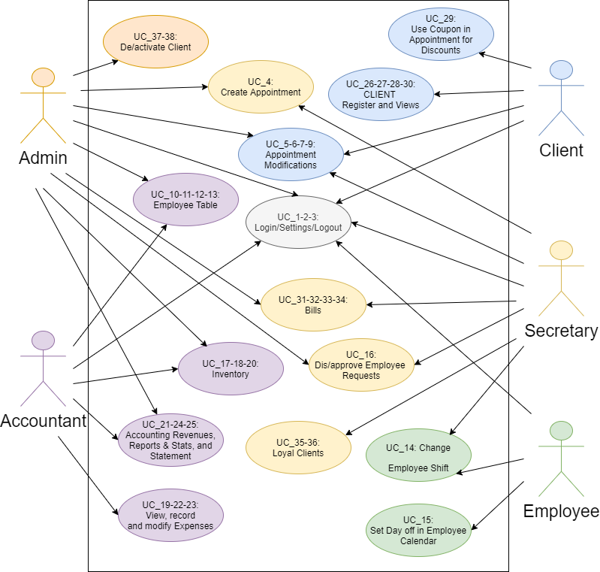

### Activity Diagram

|  |  |  |  |
| --- | --- | --- | --- |
| AC\_01\_Login  C:\Users\user\Desktop\AC_01_Login.png | AC\_02\_Settings  C:\Users\user\Desktop\AC_02_Settings.png | | |
| AC\_03\_Logout  C:\Users\user\Desktop\AC_03_Logout.png | AC\_04\_Create Appointment  C:\Users\user\Desktop\AC_04_Create Appointment.png | | | |
| AC\_05-06-07\_Accept Reschedule Reject Appointment  C:\Users\user\Desktop\AC_05-06-07_Accept Reschedule Reject Appointment.png | AC\_08\_Accept or Reject Rescheduled Appointment  C:\Users\user\Desktop\AC_08_Accept or Reject Rescheduled Appointment.png | | | | | |
| AC\_09\_ Delete Appointment  C:\Users\user\Desktop\AC_09_ Delete Appointment.png | AC\_10\_ Register Employee  C:\Users\user\Desktop\AC_10_ Register Employee.png | | | | |
| AC\_11-12-13\_ View Edit Remove Employee  C:\Users\user\Desktop\AC_11-12-13_ View Edit Remove Employee.png | AC\_14\_Change Employee Shifts  C:\Users\user\Desktop\AC_14_Change Employee Shifts.png | | | | |
| AC\_15-16\_Accept Reject Employee Requests  C:\Users\user\Desktop\AC_15-16_Accept Reject Employee Requests.png | AC\_17\_Register Inventory Item  C:\Users\user\Desktop\AC_17_Register Inventory Item.png | | | | | | |
| AC\_18\_20 Add Diminish Inventory Item  C:\Users\user\Desktop\AC_18_20 Add Diminish Inventory Item.png | | AC\_19\_Modify Invoice  C:\Users\user\Desktop\AC_19_Modify Invoice.png |

AC\_21-22-24-25 View Print Revenues Expenses, Accounting Reports

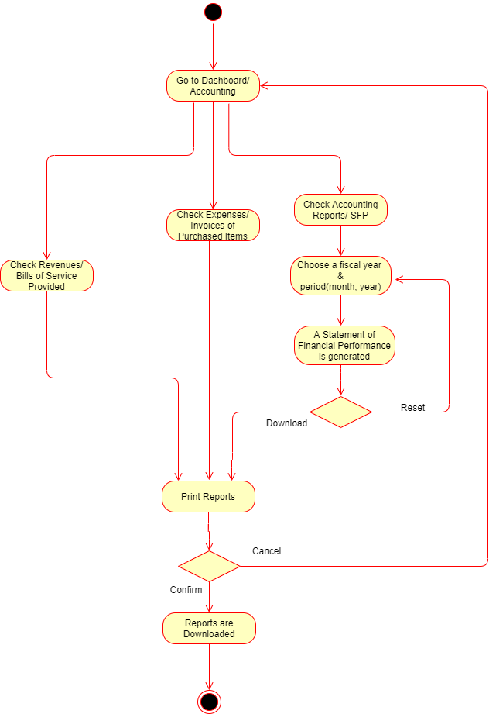

|  |  |  |  |
| --- | --- | --- | --- |
| AC\_23\_Generate Invoice  C:\Users\user\Desktop\AC_23_Generate Invoice.png | | AC\_26\_Create Personal Account  C:\Users\user\Desktop\AC_26_Create Personal Account.png | |
| AC\_27-30\_View Completed Appointments, Client Gallery  C:\Users\user\Desktop\AC_27-30_View Completed Appointments, Client Gallery.png | | AC\_28\_Redeem Discount Points  C:\Users\user\Desktop\AC_28_Redeem Discount Points.png | |
| AC\_29\_Use Coupon  C:\Users\user\Desktop\AC_29_Use Coupon.png | AC\_31-32-33-34 Generate Create Edit Print Bill  C:\Users\user\Desktop\AC_31-32-33-34 Generate Create Edit Print Bill.png | | |
| AC\_35-36\_Send Bday Message  C:\Users\user\Desktop\AC_35-36_Send Bday Message.png | | AC\_37-38\_View Deactivate Activate Client  C:\Users\user\Desktop\AC_37-38_View Deactivate Activate Client.png |

### Swim Lane Diagrams

SL\_04-05-06-07-08\_Create Accept Reschedule Reject Appointment

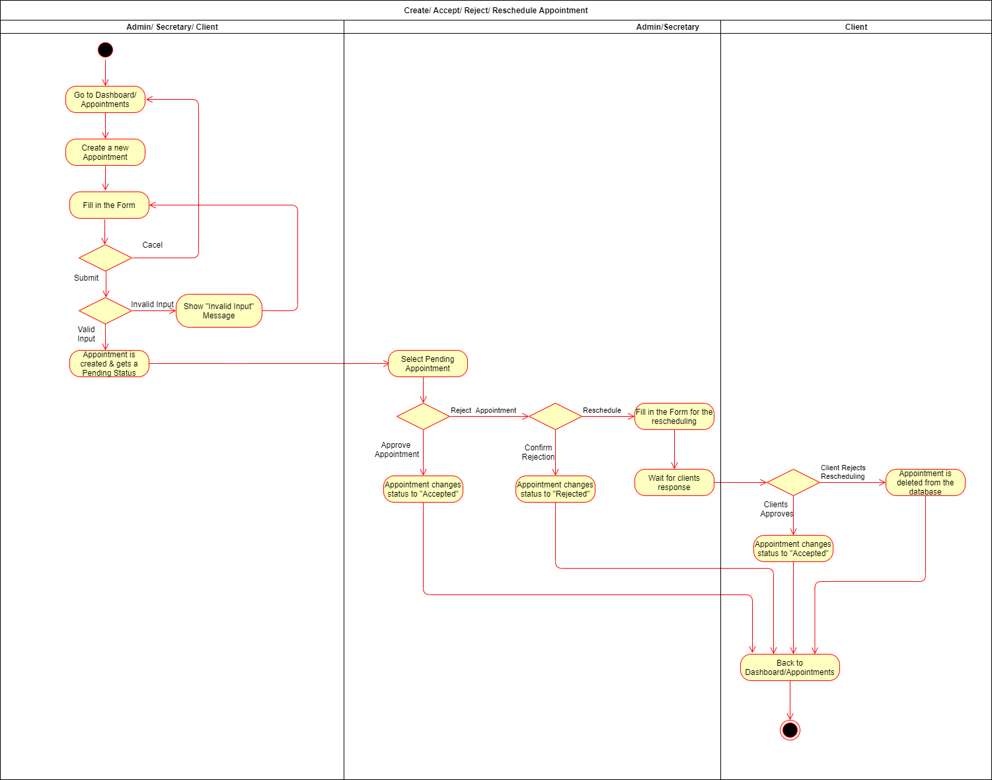

SL\_14-5-16\_Change Employee Shifts

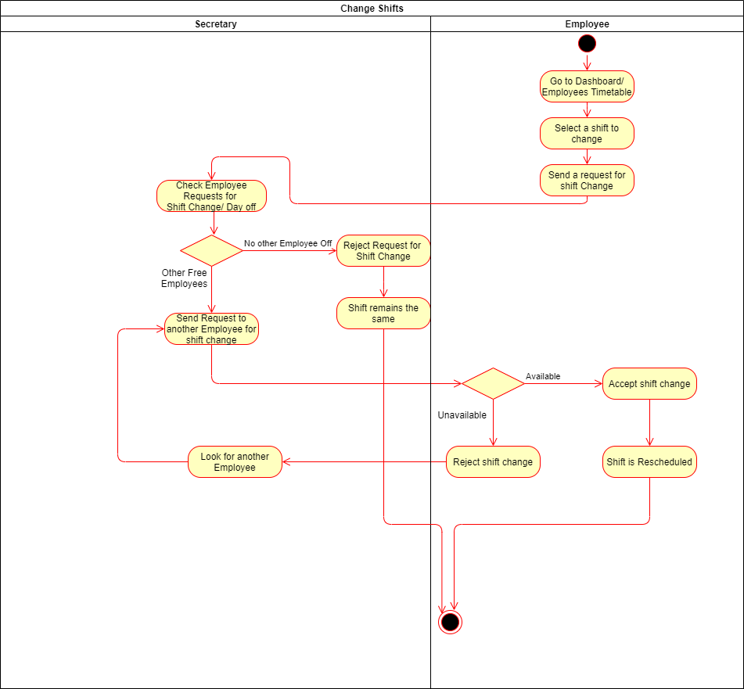

### State Chart Diagrams

ST\_01 Login

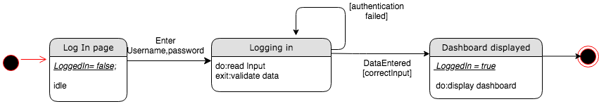

ST\_02 Settings Update

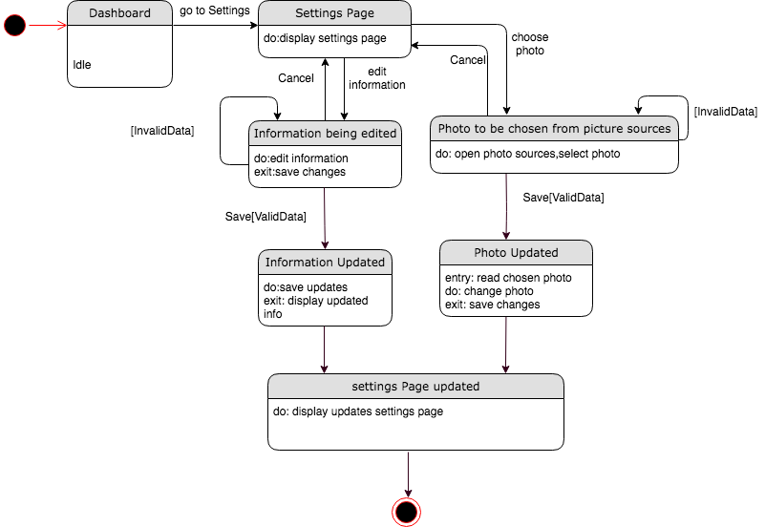

ST\_03 Log Out

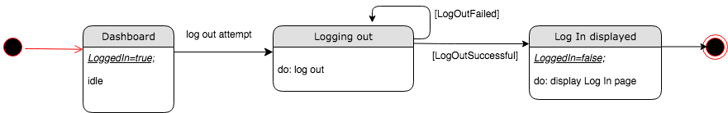

ST\_04 Create Appointment

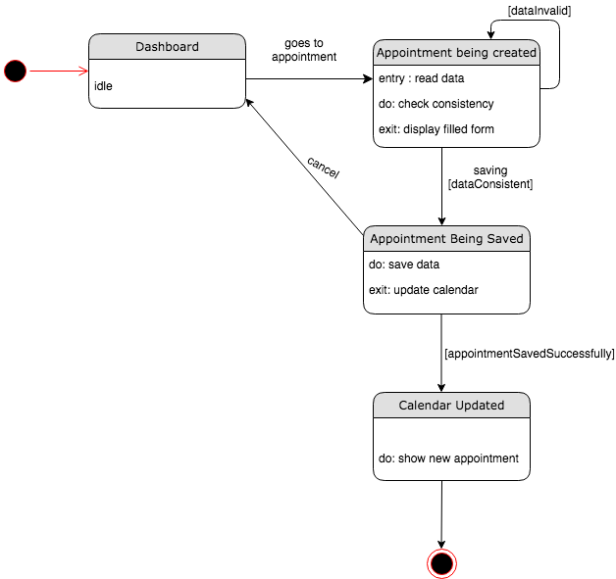

ST\_05-06-07 Accept, Reject, Reschedule Appointment

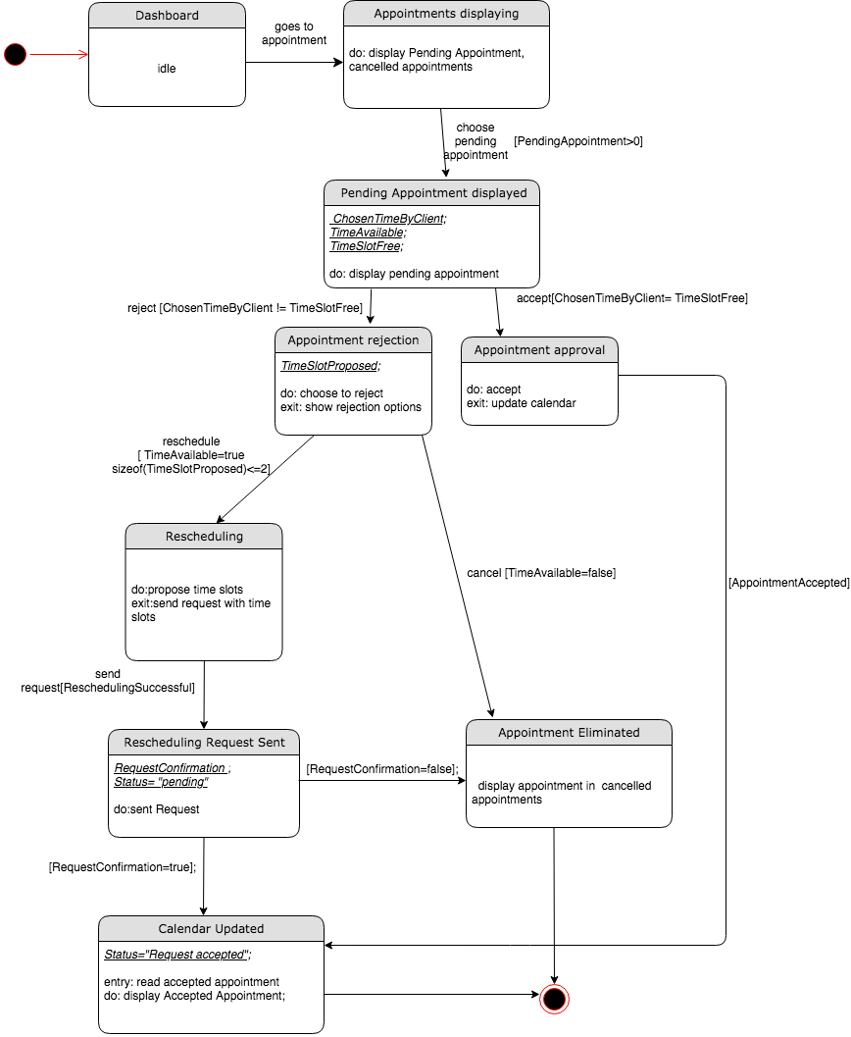

ST\_08 Accept, Reject Rescheduling

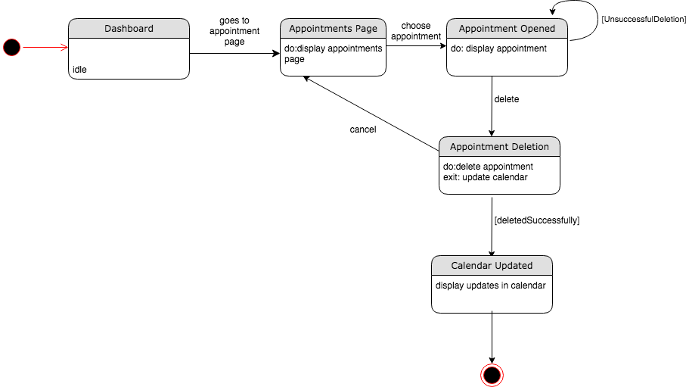

ST\_09 Delete Appointment

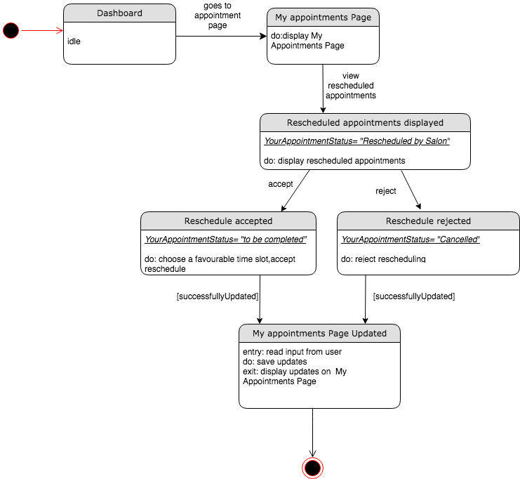

ST\_10 Register Employee

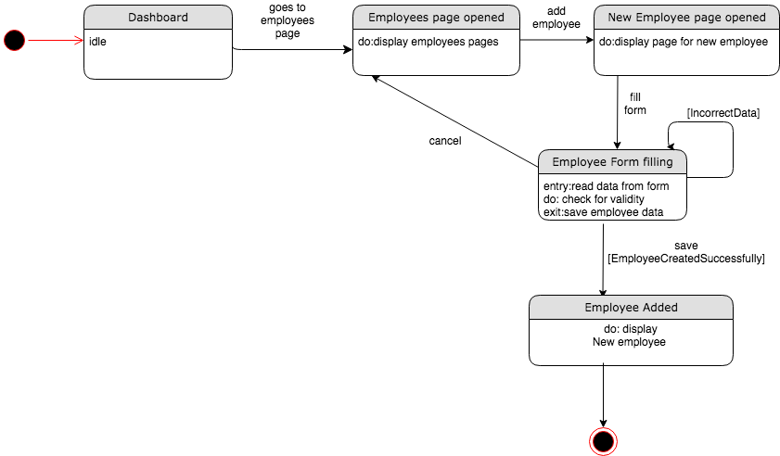

ST\_11-12-13\_ View Edit Remove Employee

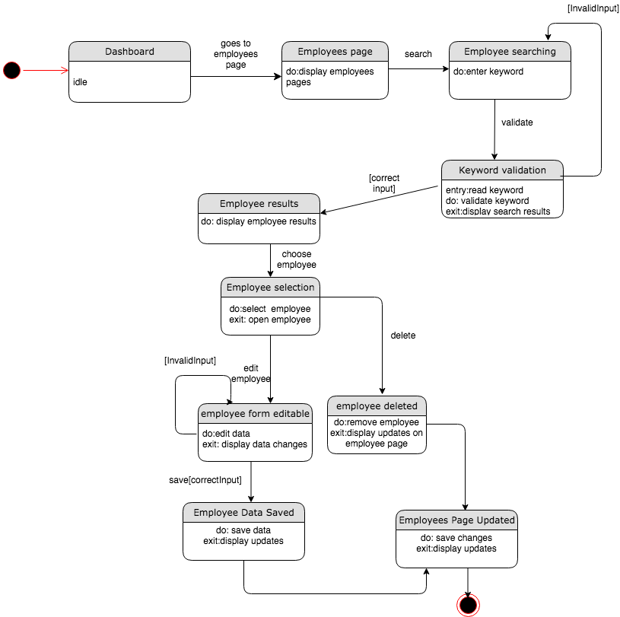

ST\_14 Change Employee Shift

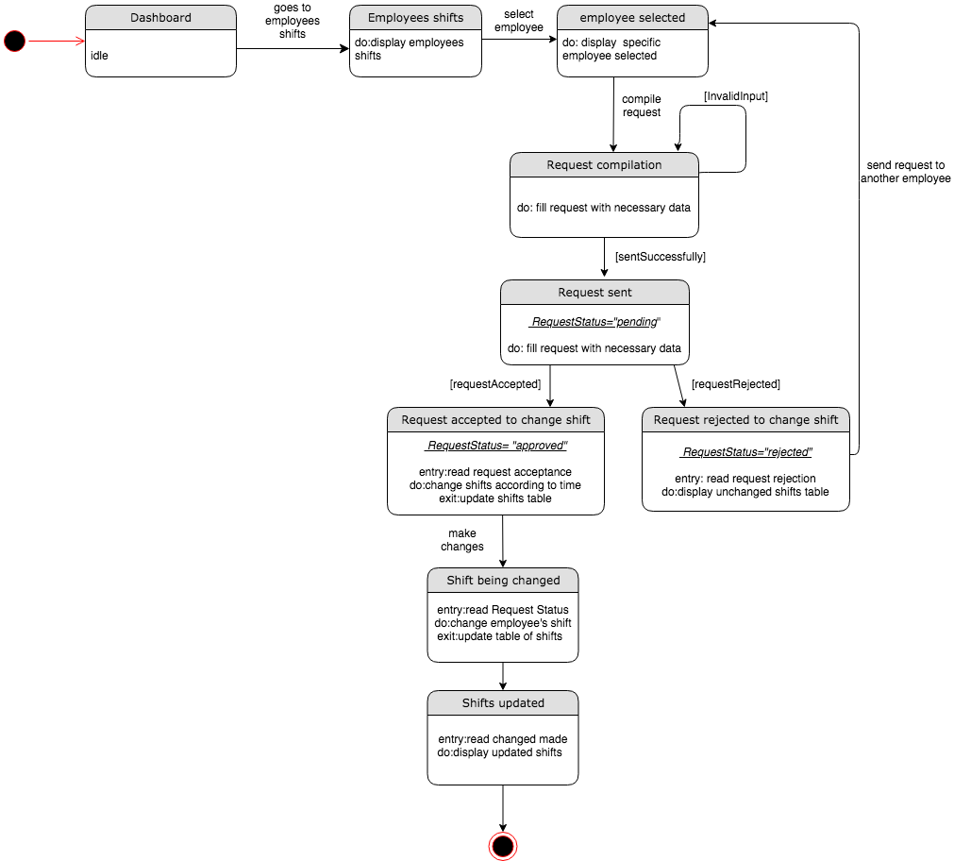

ST\_15\_16 Accept, Reject Employee Request

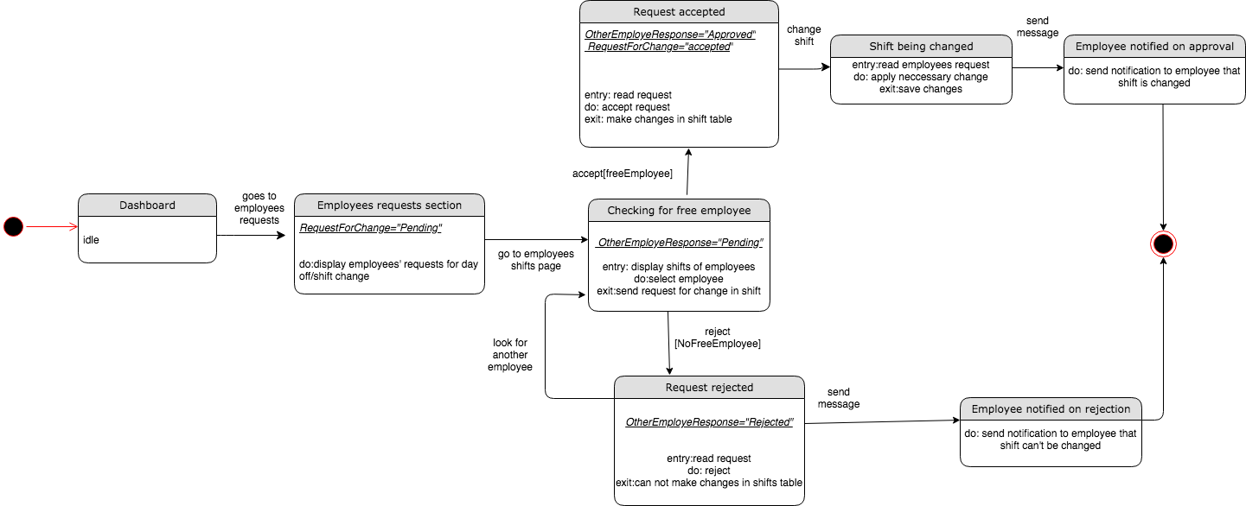

ST\_17 Register Inventory

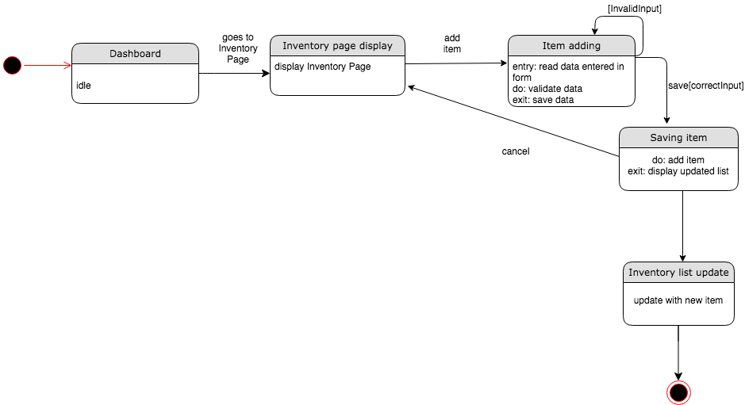

ST\_18\_20 Add Diminish Inventory

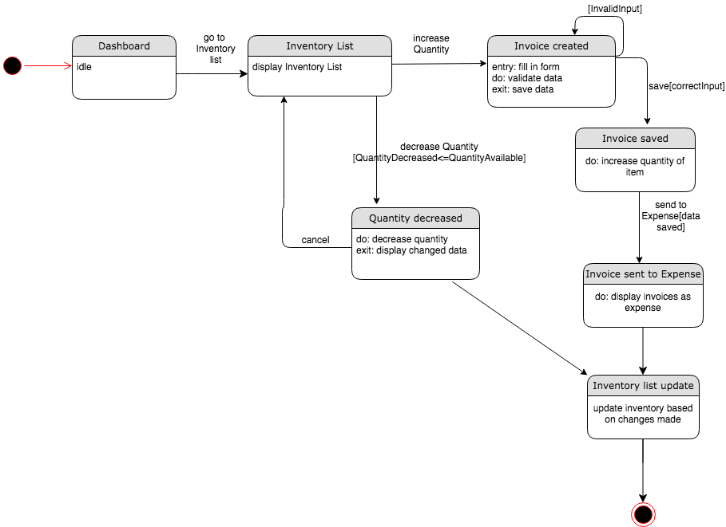

ST\_19 Modify Invoice

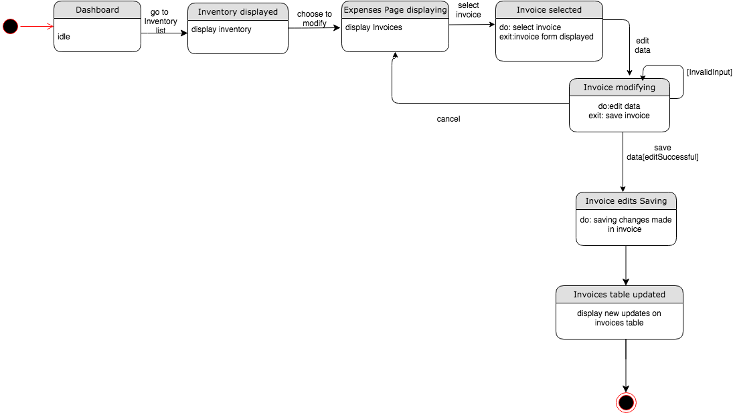

ST\_21\_22\_24\_25 View Print Revenues, Expense, Accounting Reports

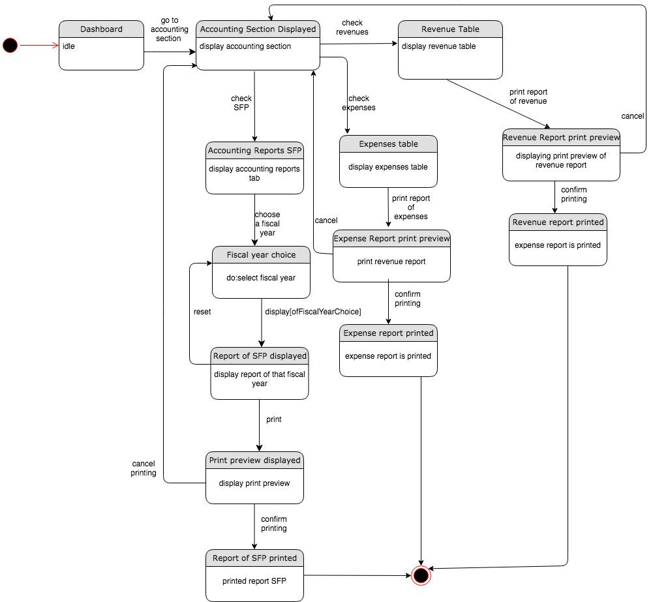

ST\_23 Generate Invoice

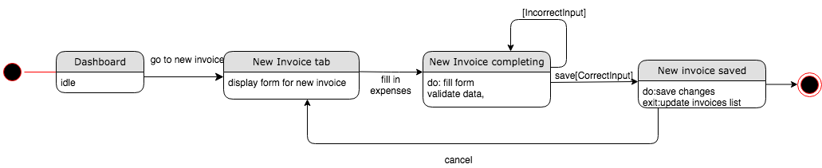

ST\_26 Create Personal Account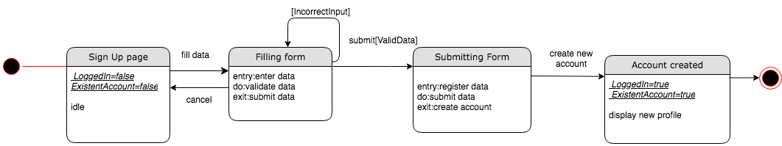

ST\_27\_30 View Completed Appointment,Client Gallery

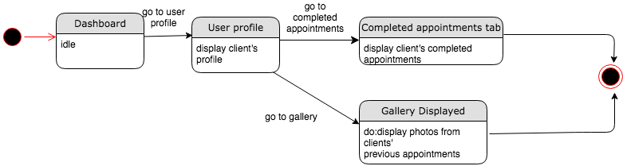

ST\_28 Redeem Discount Points

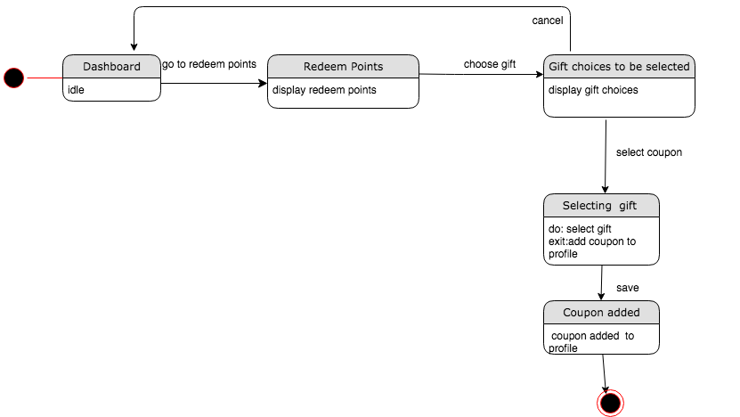

ST\_29 Use Coupon

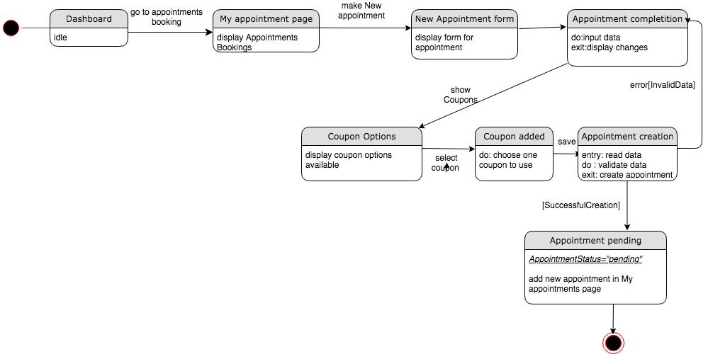

ST\_31\_32\_33\_34 Generate, Create, Edit, Print Bill

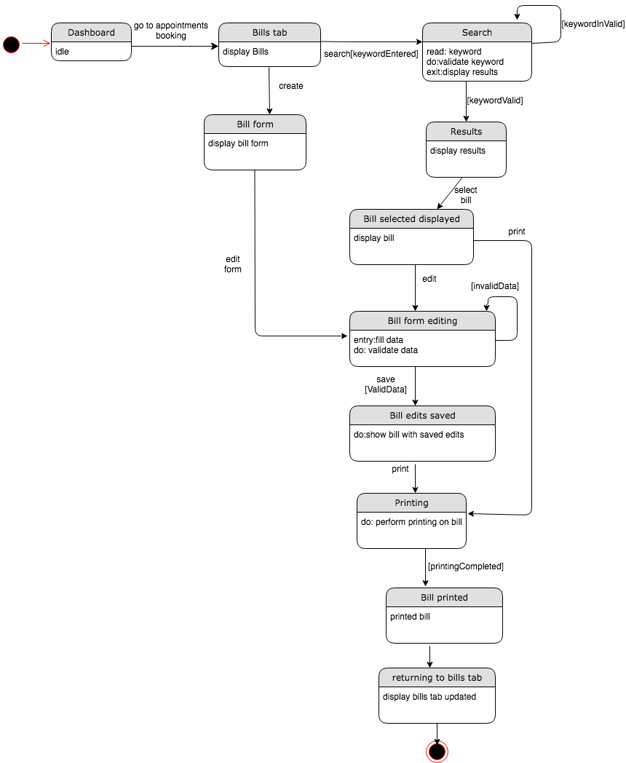

ST\_35\_36 Send B-Day Message

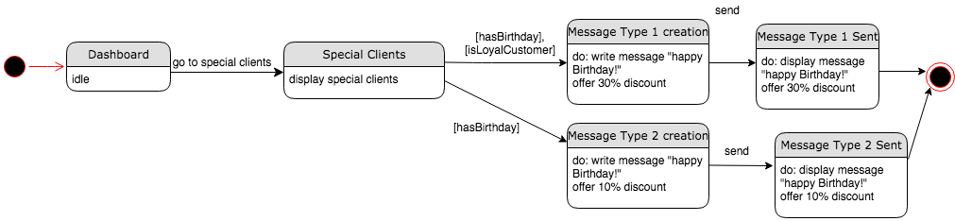

ST\_37-38 View Activate Deactivate Client

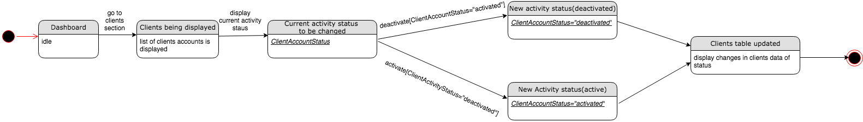

### Sequence and Collaboration Diagrams

SEQ\_01\_Login

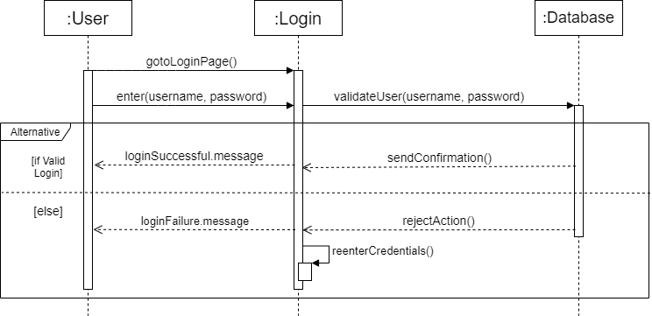

COL\_01\_Login

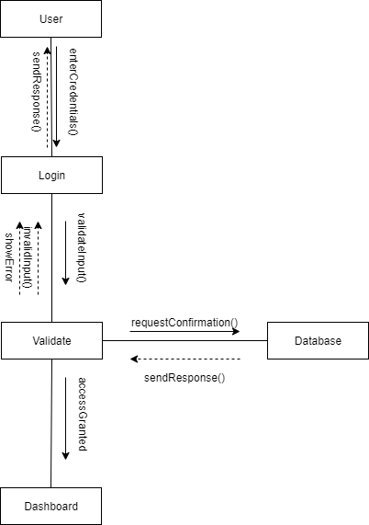

SEQ\_02\_Settings

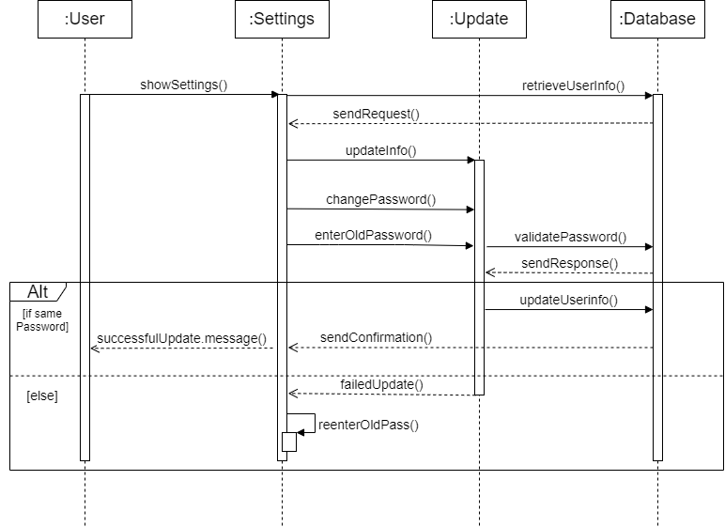

COL\_02\_Settings

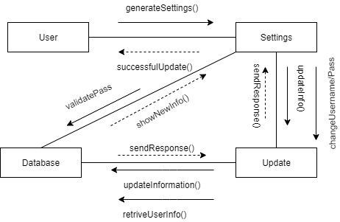

SEQ\_03\_Logout

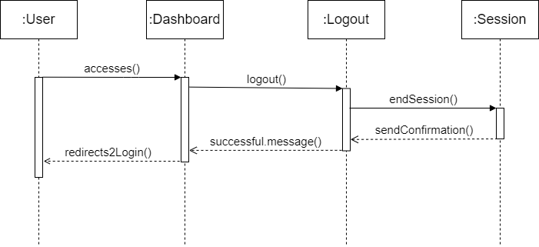

COL\_03\_Logout

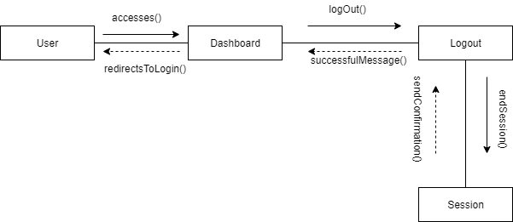

SEQ\_04-5-6-7-8-9\_Create Approve Reject Reschedule Delete Appointment

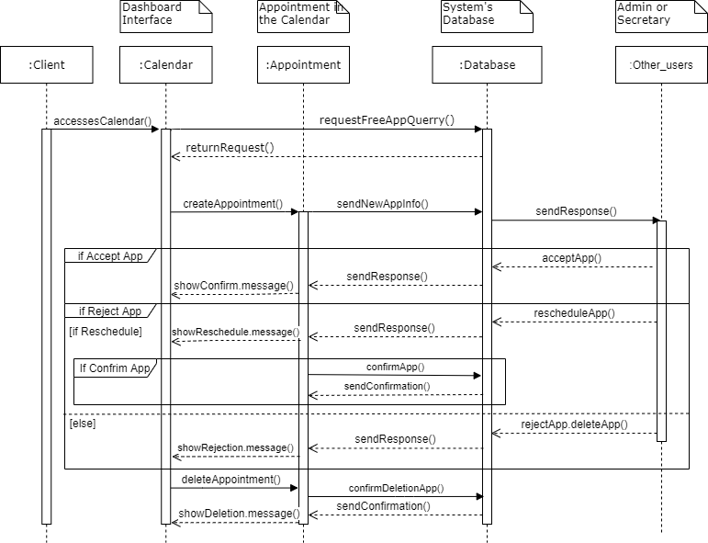

COL\_04-5-6-7-8-9\_Create Approve Reject Reschedule Delete Appointment

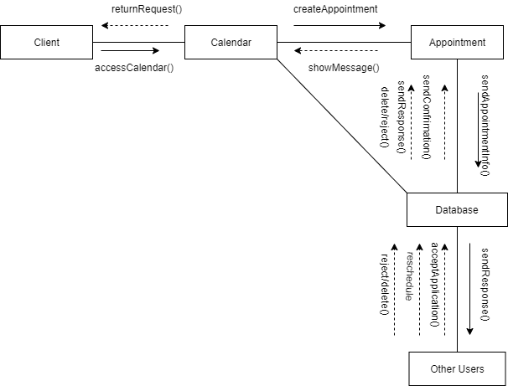

SEQ\_10-11-12-13\_Add View Edit Delete Employee

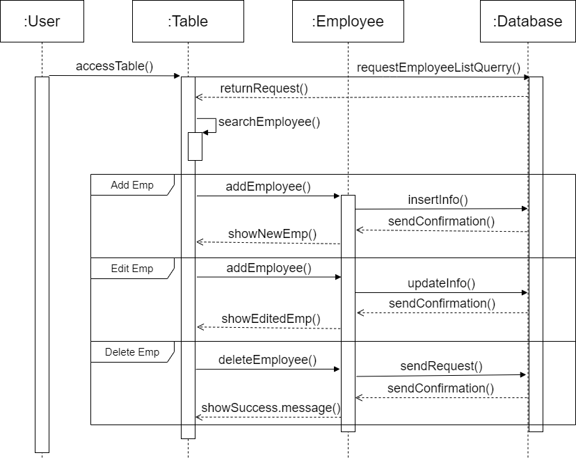

COL\_10-11-12-13\_Register view edit remove employee

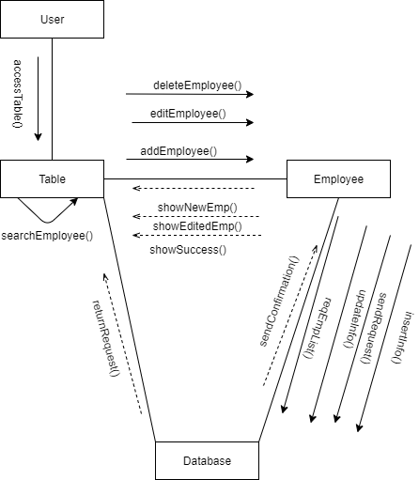

SEQ\_14-15-16\_Change Approve Reject Employee Calendar

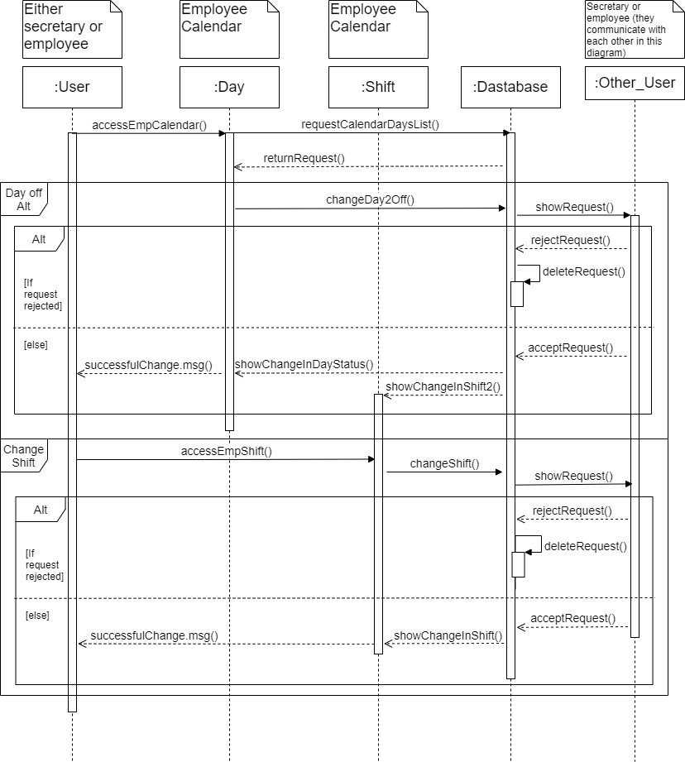

COL\_14\_15\_16\_Changeshift-Accept-Reject Employee Calendar

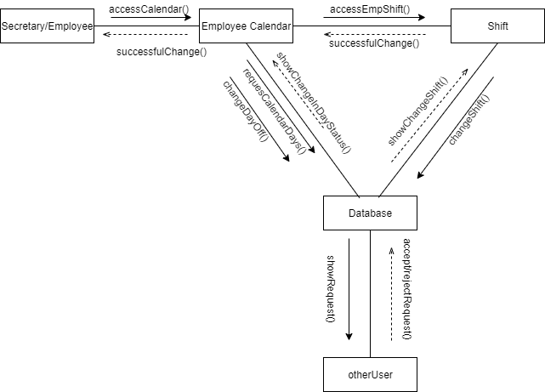

SEQ\_17-18-20\_Register Add Diminish Inventory Items

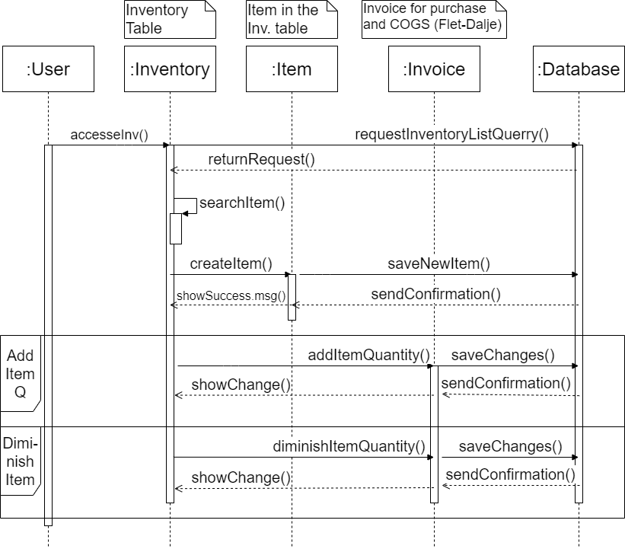

COL\_17\_18\_20\_Create-Add-Dimnish Inventory Item

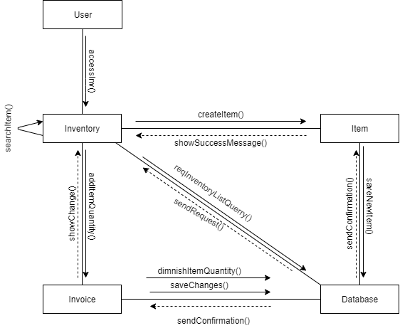

SEQ\_19-22-23-25\_View Generate Modify and Print Expenses Invoice

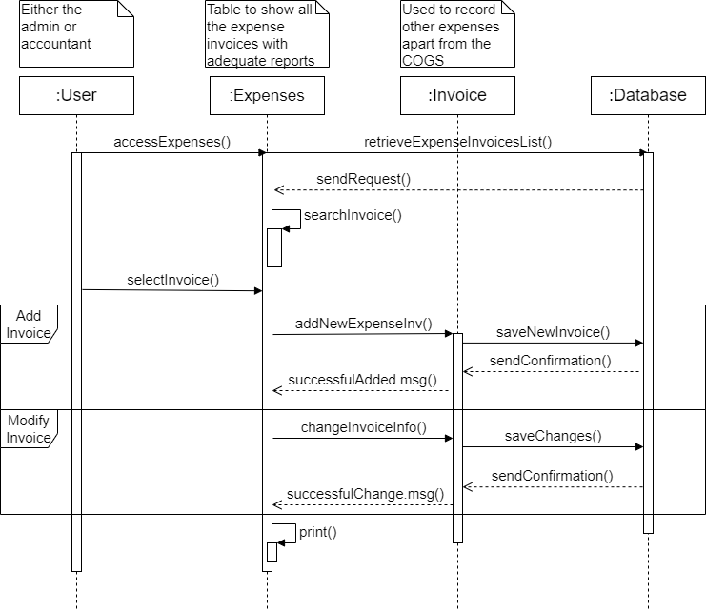

COL\_19\_22\_23\_25\_View-Generate-Modify-Print Invoices

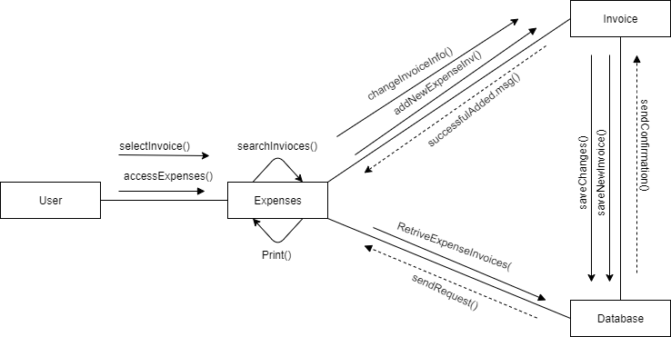

SEQ\_21-24-25\_Revenues, Statistics and Reports (Accounting)

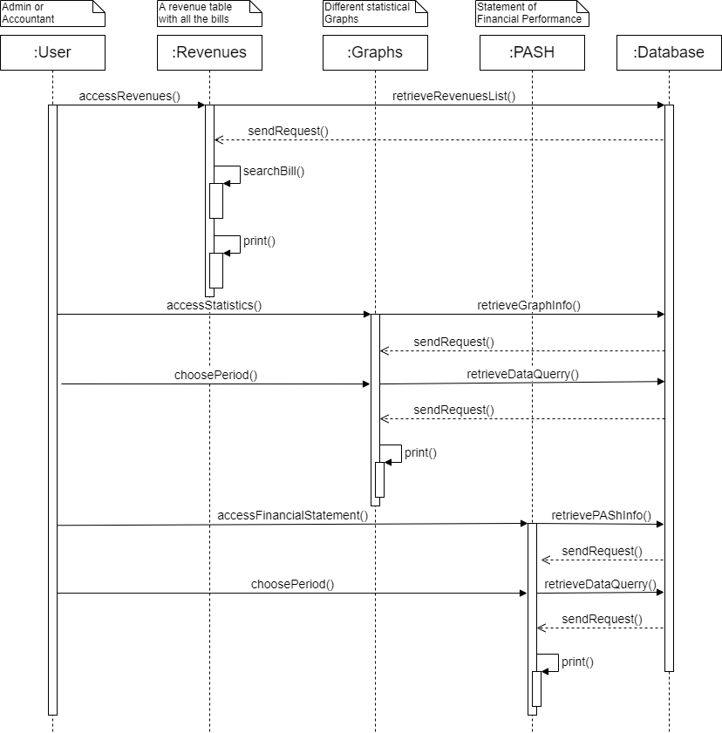

COL\_21\_24\_25\_Revenues-Statistics-Reports (accounting)

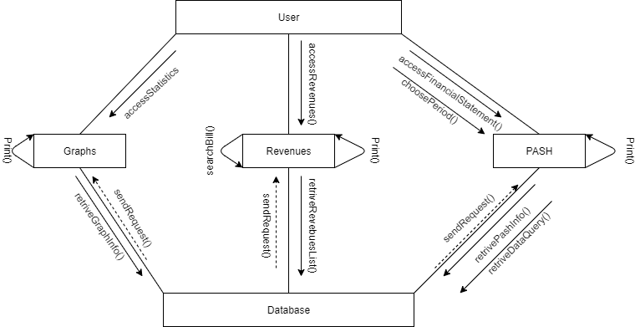

SEQ\_26\_Register Client Account

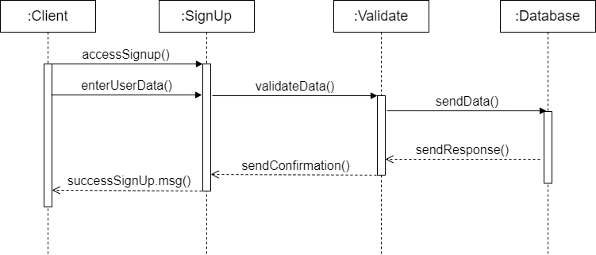

COL\_26\_Create Account

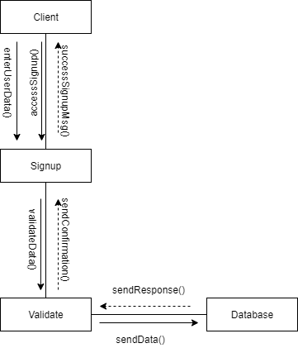

SEQ\_27-30\_View Completed Appointments and Gallery by CLIENT

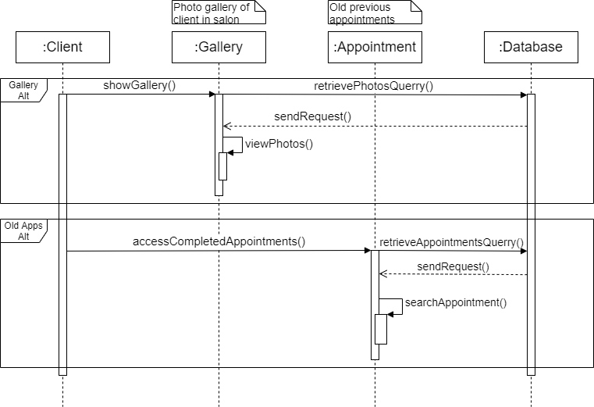

COL\_27\_30\_View Completed Appointments and Gallery by CLIENT

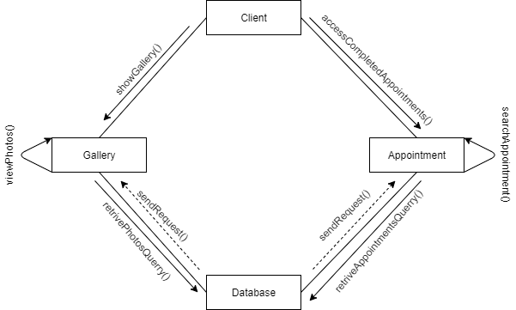

SEQ\_28-29\_Discount Points-Use Coupon

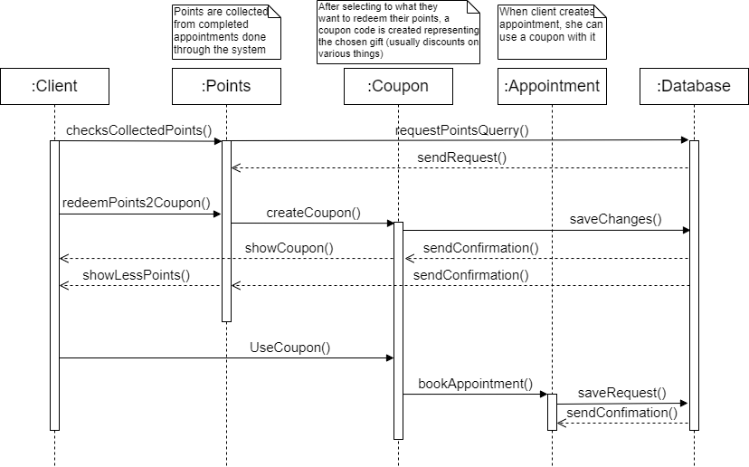

COL\_28\_29\_Discount Points-Use Coupon

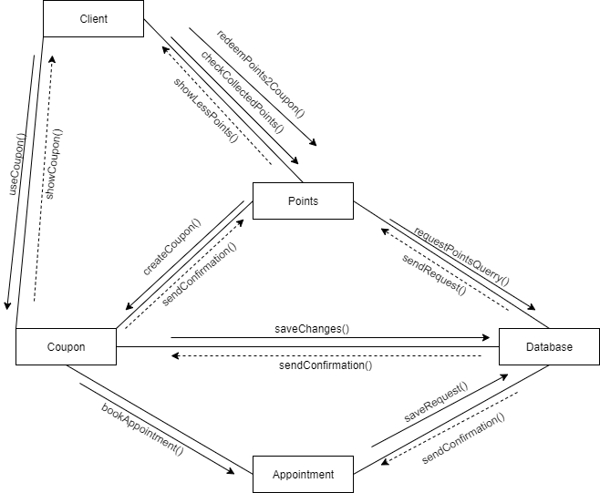

SEQ\_31-32-33-34\_Bill generation, creation, edit, and print

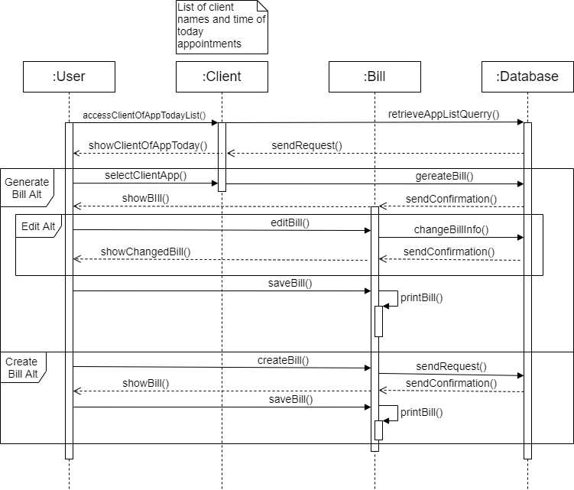

COL\_31\_32\_33\_34\_Generate-Edit-Create-Print Bills

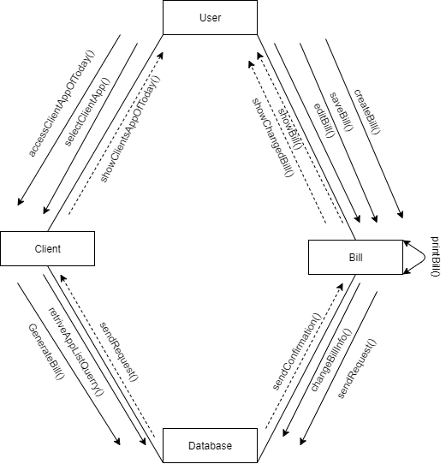

SEQ\_35-36\_View and send Birthday Message

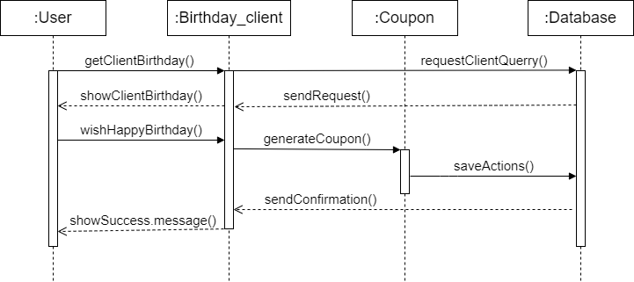

COL\_35-36\_View and send Birthday Message

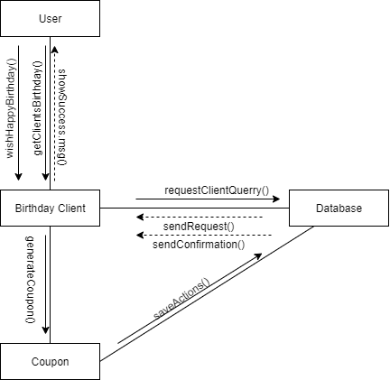

SEQ\_37-38\_View and Deactivate Clients

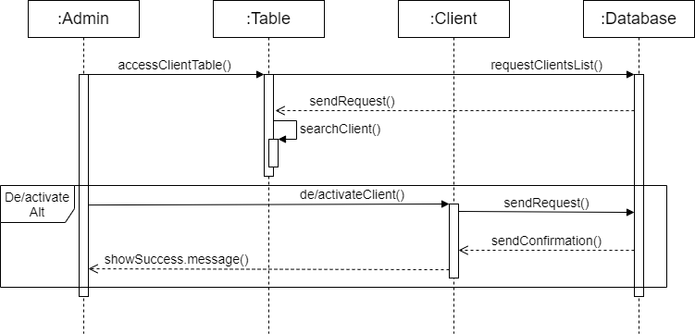

COL\_37-38\_View and Deactivate Clients

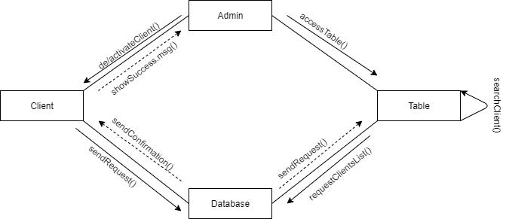

### Entity Relation Diagram

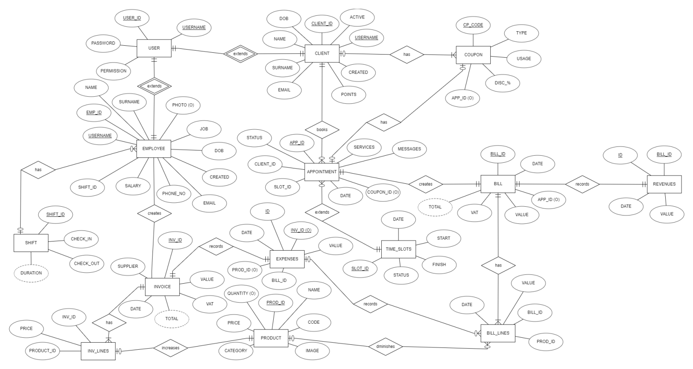

### Data Flow Diagrams

DFD: **Level Zero**

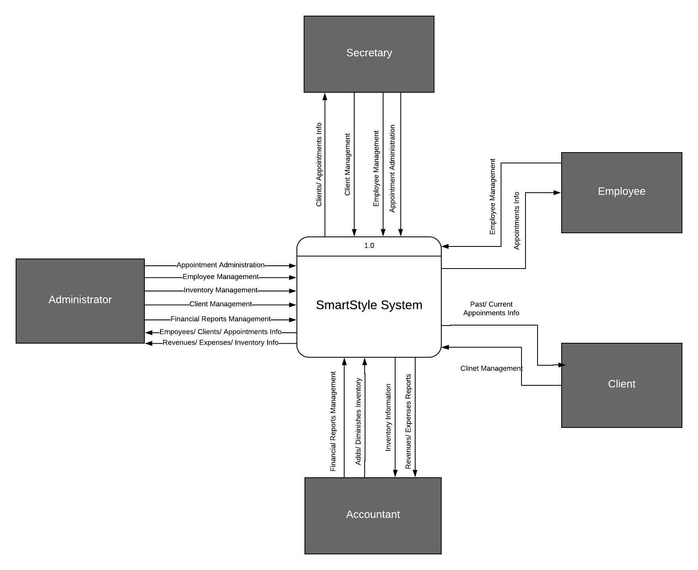

DFD: **Level One**

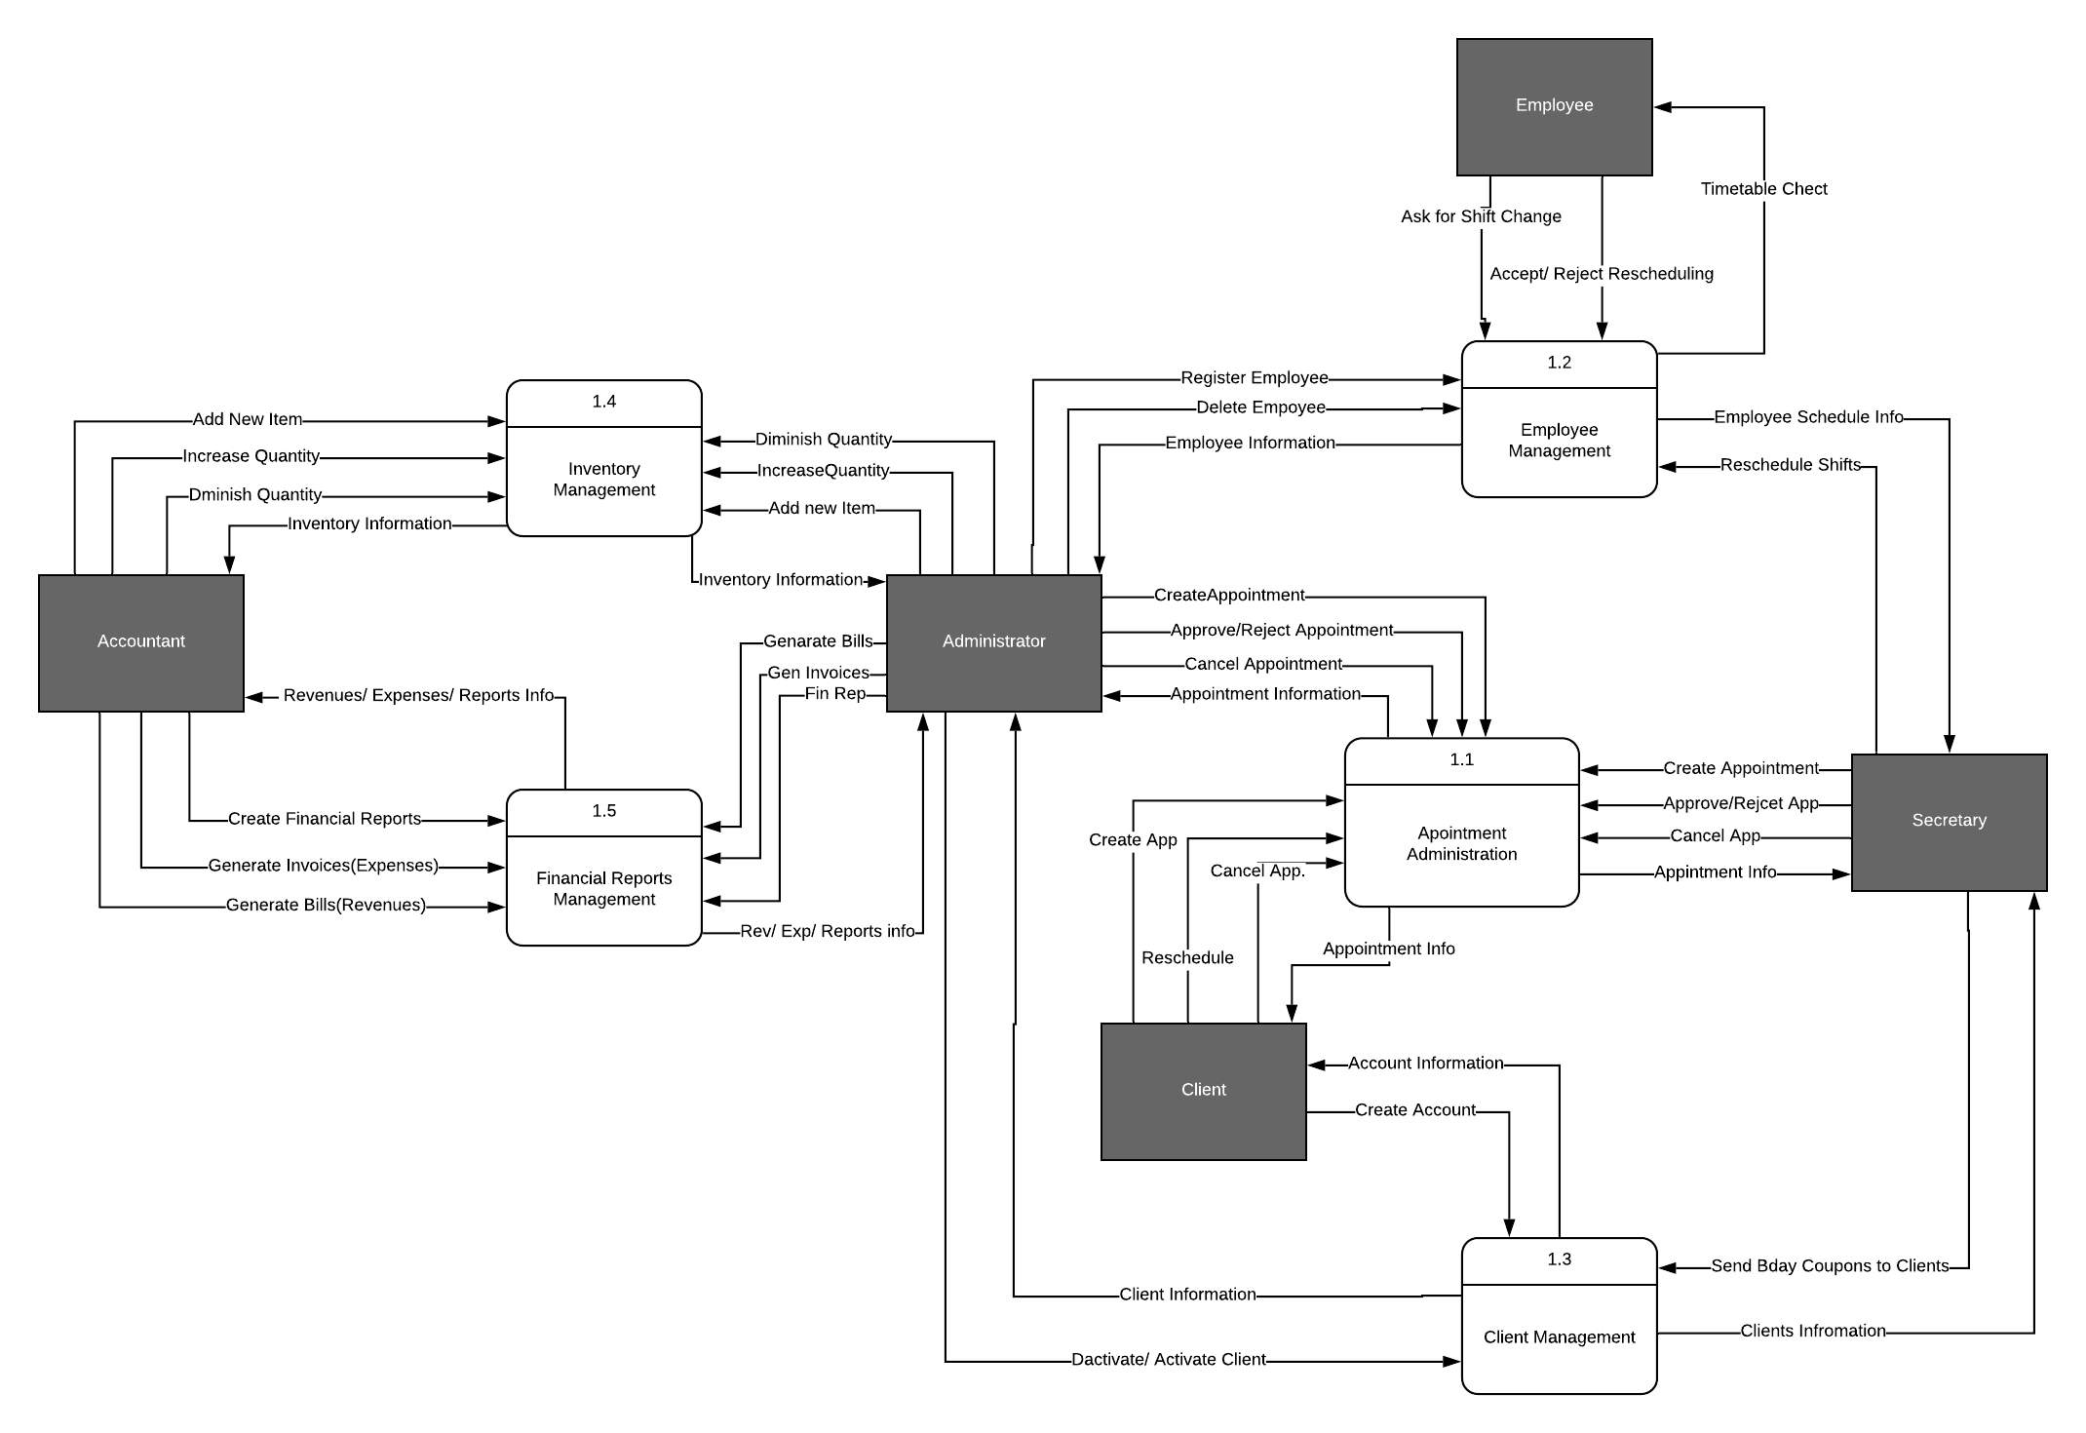

DFD: **Level Two**

**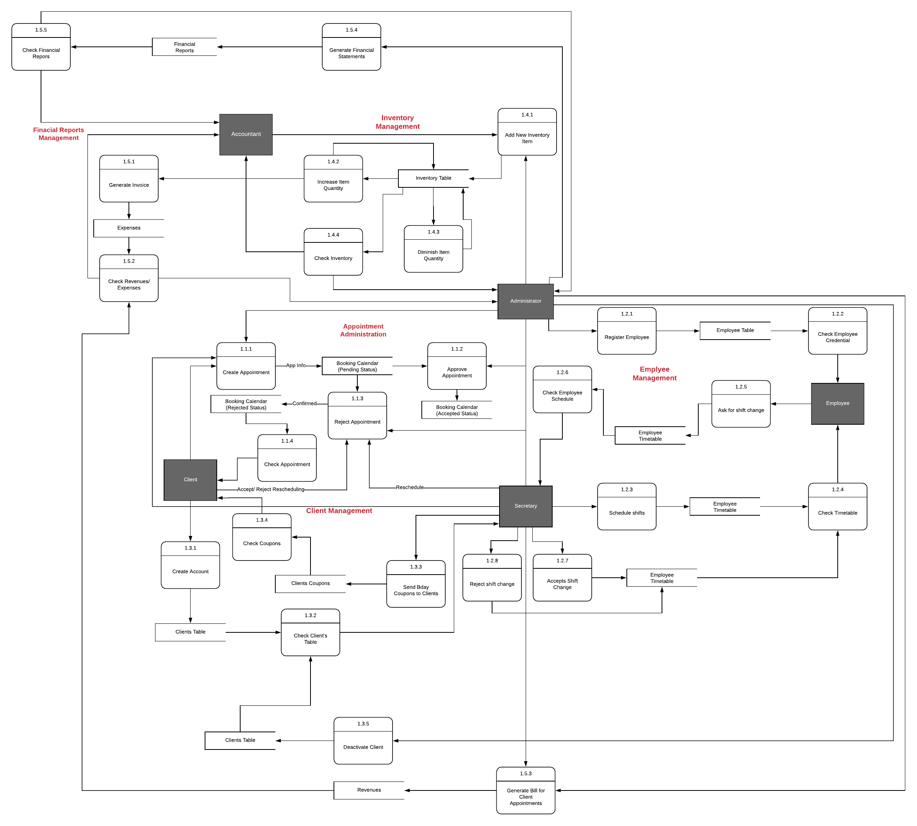**

DFD: **Level Three**

